Short Title
Relationshop Acquires Stor.ai to Create iCommerce, a Unified Engagement + eCommerce Platform for Regional Grocers and Retailers
Long Title
Relationshop Acquires Stor.ai, to Create icommerce - a disruptive enterprise platform that embeds intelligent commerce across all customer touchpoints
Magnolia, Texas
Relationshop, a digital engagement platform for retail chains, has acquired Stor.ai, a global ecommerce solution for regional grocers. The acquisition will empower regional grocers with the first of its kind, unified icommerce platform, combining operational excellence with data analytics and omni-channel engagement capabilities to increase transactions, enhance loyalty and grow sales.
The new entity will be called Stor.ai, a Relationshop company.

Stor.ai, an ecommerce & fulfillment platform for regional grocers, was founded in Israel in 2014 and is the ecommerce provider for the top grocery chains in Israel. Today, the company has over 100+ grocery customers in the USA and more than 200+ customers globally.
Relationshop’s digital experience platform offers grocers true omnichannel engagement and personalization tools for health & nutrition, loyalty & rewards programs, Email & SMS marketing, digital circulars and data analytics of online, offline and hybrid customers. Relationshop clients include well known chains such as Albertsons, United Supermarkets & Big Y Foods and is deployed in 11 regional grocery brands across the US.

Goodbye ecommerce. Hello iCommerce.
This acquisition gives retailers the ability to advance beyond ecommerce to iCommerce, said Galen Waters, CEO of Relationship. The “i” represents the tenets of our enterprise solution: intelligent data, individual engagement and integrated shopping. We believe that for regional retailers to compete with WIKA (Walmart, Instacart, Kroger, Amazon), they need a technology solutions partner and unified technology platform that drives all commerce– that’s icommerce. By merging the Relationshop shopper engagement and personalization suite with the ecommerce and fulfillment platform of Stor.ai, our clients will be able to provide a transformational and frictionless digital shopping experience to their customers, that drives both online and in store activity.
By combining the two product offerings, we will be able to provide regional grocers with a one-stop commerce solution that includes deep engagement and customer insights, said Stor.ai CEO Mendel Gniwisch. For regional chains, it is critical that we offer a cohesive shopping experience beyond what can be achieved thru bespoke third party integrations or external marketplaces.
Galen Waters will be the CEO of Stor.ai. Walters is a 50 year veteran of the retail industry. He started his career working at Safeway Stores and subsequently launched & sold Adplex, a grocery marketing start-up, to private equity. He established Relationshop in 2007 (formerly known as Go Think!). Mendel Gniwisch, former CEO of Stor.ai with 9 years of business development in technology, will be President, a member of the board and will focus his time and efforts on M&A opportunities and the international operations.

High level stats about Stor.ai, a Relationshop company:
- $1B+ in grocery ecommerce sales transacted on the platform
- 140M+ personalized product recommendations made per month
- 8M+ ecommerce transaction executed on the platform
- 500+ retail locations served in 8 countries across the globe
- 12:1 Return on digital investment for our clients
About Stor.ai, a Relationshop company
Stor.ai, a Relationshop company, empowers regional grocers with the first of its kind, unified icommerce platform, combining operational excellence with data analytics and omni-channel engagement capabilities to increase transactions, enhance loyalty and grow sales. The platform offers grocers true omnichannel engagement and personalization tools for health & nutrition, loyalty & reward programs, Email & SMS marketing, digital circulars and data analytics for online, offline and hybrid customers. Clients include well known chains such as Albertsons, United Supermarkets & Big Y Foods and is deployed in over 500 retail locations across 8 countries. To learn more, visit: www.stor.ai
For more information, please contact:
Head of Stor.ai Marketing
Shmuel Tennnehuas
shmuel.t@stor.ai
917-406-5088

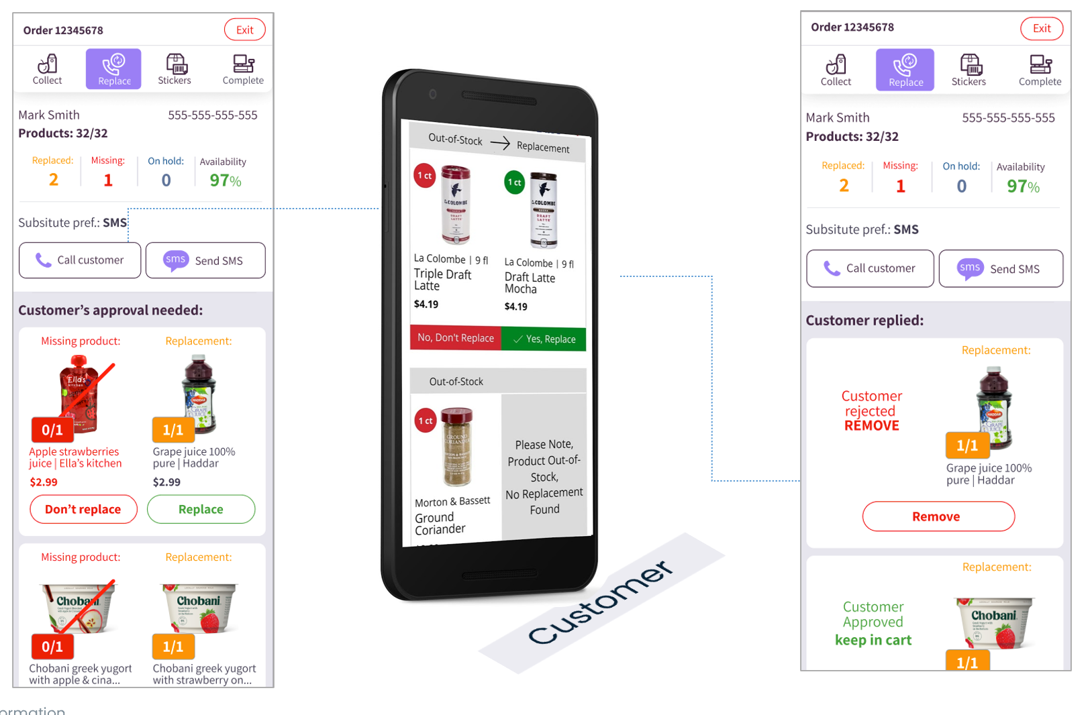
product screenshot from the Stor.ai picking application
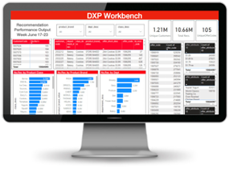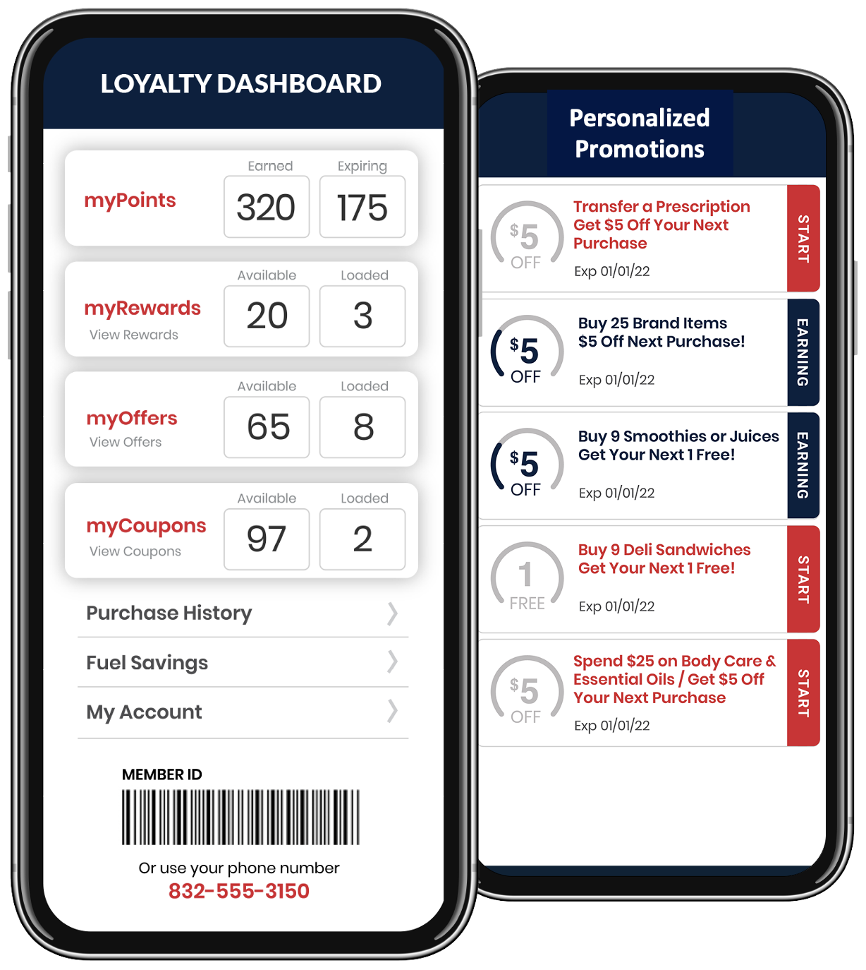
Product screenshot of the Relationship KPI dashboard and customer loyalty and promotion screens

